Batch: C1 Roll No.: 16010122221

Experiment No. 02

Grade: AA / AB / BB / BC / CC / CD /DD

Signature of the Staff In-charge with date

Title: Implementation of ‘McCulloch Pitts Net for NAND and AND NOT function
___________________________________________________________________________________
Objective: To implement MP Neuron Model for the NAND and AND NOT logical function
___________________________________________________________________________________
Expected Outcome of Experiment:

CO1 : Identify and describe soft computing techniques and their roles ____________________________________________________________________________________
Books/ Journals/ Websites referred:

_________________________________________________________________________________
Pre Lab/ Prior Concepts:

McCulloch-Pitts Neuron

The first computational model of a neuron was proposed by Warren MuCulloch (neuroscientist) and Walter Pitts (logician) in 1943.

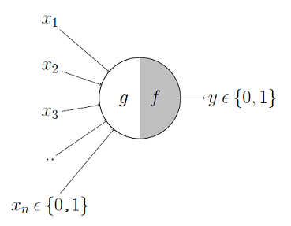

It may be divided into 2 parts. The first part, g takes an input (ahem dendrite ahem), performs an aggregation and based on the aggregated value the second part, f makes a decision.

These inputs can either be excitatory or inhibitory. Inhibitory inputs are those that have maximum effect on the decision making irrespective of other inputs i.e., if the inhibitory input is ON than the neuron will never fire. Excitatory inputs are NOT the ones that will make the neuron fire on their own but they might fire it when combined together. Formally, this is what is going on:
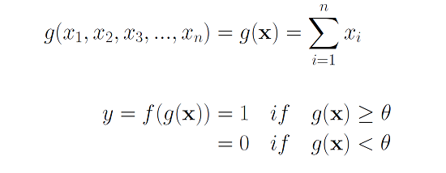
We can see that g(x) is just doing a sum of the inputs — a simple aggregation. And theta here is called thresholding parameter. For example, if I always watch the game when the sum turns out to be 2 or more, the theta is 2 here. This is called the Thresholding Logic.

Boolean Functions Using M-P Neuron

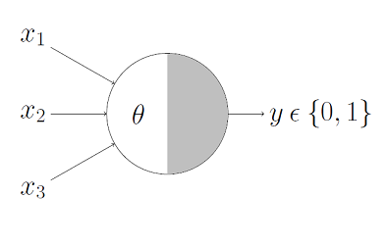

This representation just denotes that, for the Boolean inputs x_1, x_2 and x_3 if the g(x) i.e., sum ≥ theta, the neuron will fire otherwise, it won’t.

AND Function
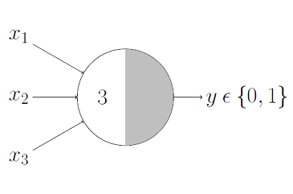
An AND function neuron would only fire when ALL the inputs are ON i.e., g(x) ≥ 3 here.
OR Function
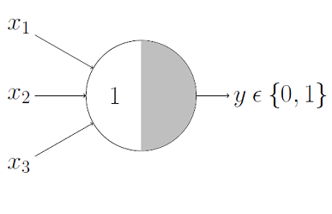
I believe this is self explanatory as we know that an OR function neuron would fire if ANY of the inputs is ON i.e., g(x) ≥ 1 here.

AND NOT function (write here)

NAND function (write here)

____________________________________________________________________________________
Implementation Details:

Write the code for implementation of MP neuron model for NAND and AND NOT function

Code:
#Paste the code here

Output:
#

Conclusion: Thus, we have successfully implemented MP neuron model for NAND and AND NOT logical function

Post Lab Descriptive Questions:

- Discuss the limitations of MP neuron model
- Explain with an example the concept of linear separability and Justify NOT XOR function is not linearly separable.

.

Date: _____________ Signature of faculty in-charge

